Architects Notebook.

# Purpose:

The purpose of this document is to describe programming approaches and standards for the DSTC e conference web application software. It will also outline the sub-systems of the application. It will be updated throughout the development process with notes and information pertaining to the software design of the project. It will be co-authored by the three software architects assigned to the project.

# Sub-systems:

The two main parts of the system are the Mobile Application and the Web application. The mobile application will be used by the attendees, and the web application will be a console for the conference administrator(s).

The following diagram describes the sub system relationships.

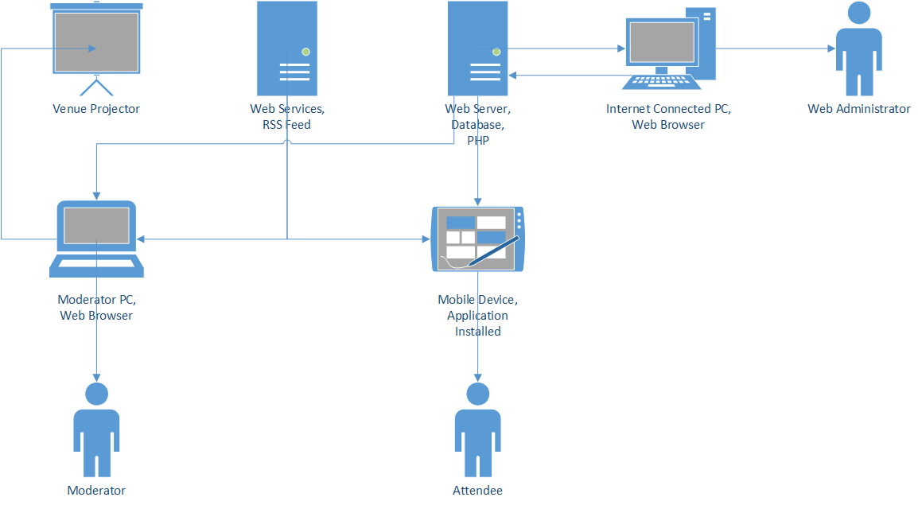

# Standards:

## Language versions:

* HTML 1.0 (W3C validated)
* PHP 5.x
* JAVASCRIPT 1.8.5
* CSS 3

## IDEs and dev tools:

* Dreamweaver
* Netbeans
* PHPEdit
* GitHuB
* SourceTree

## Target Browsers:

* Chrome v33+
* Firefox v25+
* IE v9+

## Changelogs:

Each developer should keep a list of all changes made to the code, to be updated while developing. This document should be separated into coding sessions with a date and time, and feature a list of changes.

## Debugging:

Please make extensive use of debugging tools like the javascript log and PHP error reporting.  
At the end of each programming session please note a list of known bugs in your new code.

## Code comments:

Please head all code functions with a description of their purpose and an author name.

If the function has a return value and/or arguments, please include a description of these as well.

**// getTable($tablename)  
// Fetches a table from the database.  
// Arg: $tablename - the name of the table to be fetched.  
// Returns: A PDO table array of the specified table.  
// Last updated by: Andy.**

Please include placeholder comments for future/unfinished functionality. For example:

**// TODO: add database functionality  
// add presentation code**

Please add inline comments for complex or obtuse lines of code.

## Coding Readability:

For the web application, the following coding style guide should be implemented.

Please use curly brackets in the "java textbook" style:

**if(something) {  
 this;  
}  
else {  
 this;  
}**

Please use 4 space tabs.

For HTML attribute values, please use single quotation marks.

**<p id='this'>is good!</p>**

And PHP and JS literals with double quotations.

**var hi = “hello”;**

Please comment all PHP code with a description of functions.

# Programming approaches:

## Site File Structure for the Web Application:

**/ROOT**

This is the root directory that holds the index.php and all other directories. The index.php is the “main page” and is a compound php script that combines the scripts in the HTML_INCLUDE directory.

**/ASSETS**

This directory will hold all the images and other media in use for the website.

**/CSS**

This directory will hold all the external cascading style sheets for the website.

**/HTML_INCLUDE**

This directory will hold the following scripts, which are modular sections or divisions of the website.

* onLoad.php: this script will execute once each time a new page loads.
* header.php: this script will layout the page header.
* nav.php: this script will contain the navigation bar.
* content.php: this script will load the correct page content.
* footer.php: this script will layout the page footer.

**/PHP_BLL**

This directory will contain scripts that hold the business logic layer functions. For example, Account authorisation.

**/PHP_DB**

This directory will contain the database access layer functions. A lot of the database calls will actually reside in the presentation layer.

**/PHP_PRES**

This directory will contain the view and edit scripts for the main contents of the site. This directory will be where most of the content will go.

**/PHP_VALIDATION**

This directory will contain validation scripts for server side validation of data before it gets committed to the database.

**/SCRIPTS_TEAM**

This directory will contain any javascript functions written by the team required for the website.

**/SCRIPTS_THIRD_PARTY**

This directory will contain any third party javascript libraries.

## General design notes for the Web Application:

The client has chosen the prototype that is best described as a “lightweight and powerful administrative console”.  
No design features should be included that were not a part of the chosen prototype.  
The web app will feature limited styling and images and no reliance on third party styling libraries.  
The navigation system will be a simple navigation ribbon across the top underneath the header. Some options will be hidden within drop down sub-menu items.  
The design will be as modular as possible, to allow the development team to work asynchronously on different, self-contained pages.  
The “main page” is separated into 4 sub-divisions or parts of the page. Three of those sections, the header, navbar, and footer will remain the same across all pages. The content division will be the dynamic presentation section, controlled by user navigation.  
Each presentation section (i.e. sessions, polls, etc) will have a similar structure. They will each have a:

* View data page
* Edit data page
* Add data page
* Delete data page

Each of these pages can be developed from a single template, utilising existing code libraries and styling options.  
Form validation will be server side only, implemented in PHP scripts.

## Specific Design notes for the Web Application:

* Web application to handle two types of user groups.
  + Admin User has full permission for all functionalities.
  + Able to create conference, add user and assign conference to a selected user.
  + Other users can manage assigned conference and all the other functions but cannot create or clone a new conference.
  + All users are able to change their password.
* Users are only allowed to view or manage the conferences assigned to them by the administrator.
* Display conference view with respect to the user logged into the system.
* Display conference section view with respect to the user logged into the system.
* Display conference session view with respect to the user logged into the system.
* Design change in the form page to display the forms and section for the selected conference and the logged user.
* Feedback page to display the questions with respect to the conference or session and logged user.